AIM-Solution of differential equation using Runge-Kutta Methods

THEORY-
Let an initial value problem be specified as follows:
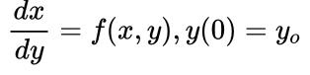

where initial value of x i.e x₀=0
initial value of y i.e y₀=y₀

Now choose the value of h(step height) and define :

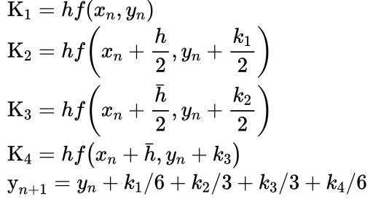

Here value of n are 0, 1, 2, 3, ….(x – x0)/h.
xn+1 = x0 + h

The formula basically main objective is to find the next value yn+1 using current yn plus weighted average of four increments.

- k1 is the increment based on the slope at the beginning of the interval, using y
- k2 is the increment based on the slope at the midpoint of the interval, using y + hk1/2.
- k3 is again the increment based on the slope at the midpoint, using using y + hk2/2.
- k4 is the increment based on the slope at the end of the interval, using y + hk3.

ALGORITHM-

1. Start

2. Define function f(x,y)

3. Read values of initial condition(x0 and y0),
number of steps (n) and calculation point (xn)

4. Calculate step size (h) = (xn - x0)/n

5. Set i=0

6. Loop
k1 = h * f(x0, y0)
k2 = h * f(x0+h/2, y0+k1/2)
k3 = h * f(x0+h/2, y0+k2/2)
k4 = h * f(x0+h, y0+k3)
k = (k1+2*k2+2*k3+k4)/6
yn = y0 + k
i = i + 1
x0 = x0 + h
y0 = yn
While i < n

7. Display yn as result

8. Stop

CODE-

#include<iostream>
#include<math.h>
#define f(x,y) -2*x*pow(y,2)
using namespace std;

int main()
{
float x0, y0, xn, h, yn, k1, k2, k3, k4, k;
int i, n;
cout<<"Enter Initial Condition"<< endl;
cout<<"x0 = ";
cin>> x0;
cout<<"y0 = ";
cin >> y0;
cout<<"Enter calculation point xn = ";
cin>>xn;
cout<<"Enter the Step Size = ";
cin>>h;
n = (int)((xn - x0) / h);
/* Runge Kutta Method */
cout<<"\nx0\t\ty0\t\ty(x0)\n";
cout<<"-----------------------------------\n";
for(i=0; i <=n ; i++)
{
k1 = h * (f(x0, y0));
k2 = h * (f((x0+h/2), (y0+k1/2)));
k3 = h * (f((x0+h/2), (y0+k2/2)));
k4 = h * (f((x0+h), (y0+k3)));
k = (k1+2*k2+2*k3+k4)/6;
yn = y0 + k;
cout<<x0<<"\t\t"<<y0<<"\t\t"<<yn<<"\n";
x0 = x0+h;
y0 = yn;
}
return 0;
}

OUTPUT-
